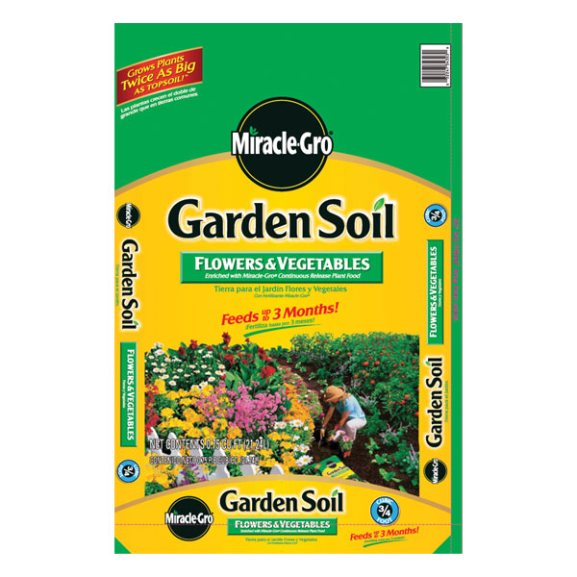
Flower & Veggies Soil
- 1 Cubic Foot
- Naturally Formulated
- Continuous Release

$5.99
7102692

